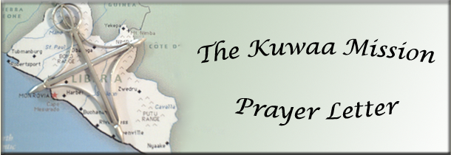

**August 2013 2013**

**August 2013 KUWAA MISSION PRAYER LETTER**

**In February 2014 the Kuwaa Mission will celebrate its 5th anniversary with thanksgiving to God for what he accomplished through the efforts of the mission. So please join us before God’s throne in praise and prayer.**

**Praise Items:**

* Praise God that each of the 16 towns has at least one well
* Praise God that a large number of water purification filters were handed out
* Praise God for all the medical supplies that were provided for the mid-wives, the Fassama clinic, and the small medical dispensaries
* Praise God for the Kondesu Clinic which will be completed and dedicated this coming dry season
* Praise God for the school and student supplies the mission was able to hand out
* Praise God for the religious materials the mission was able to hand out
* Praise God for the successful training workshops that were held and well attended
* Praise God for the scholarships for 3 evangelists and 1 nurse
* Praise God for the organizations that have partnered with us in helping the Kuwaa people over the first 5 years – Wheat Ridge, The Lutheran Church in Liberia, Samaritan’s Purse, Child Care, Joe Boway’s mission, and the Liberian government
* Praise God for the Kuwaa people’s willingness to donate their time and labor in work projects
* Praise God for the faithful prayer and support warriors who made all this possible.

**Prayer Items:**

* 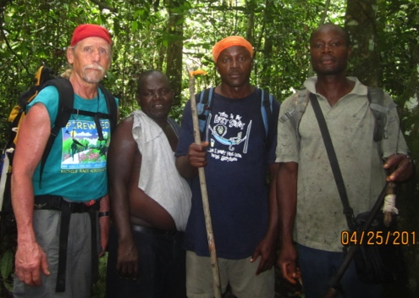Pray for the physical and spiritual welfare of the Kuwaa people
* Pray for the Kuwaa Mission’s leadership that they remain faithful in their calling to serve through the mission.
* Pray for more doors to be opened to help the Kuwaa people
* Pray for wisdom among the Board members to discern where God is leading the mission
* Pray for Stan Olsen as he continues to lead the mission as its C.E.O.
* Pray for God to continue the restoring of the Kuwaa people’s hope
* Pray for more volunteers to help with the work

Stan Olsen with some Kuwaa Workers

* Pray for the new board members that they would find fulfillment in this work.
* Pray for the Liberian pastors especially those who are suffering PTSD from the civil war.
* Pray for God to bless the mission so that medical equipment and furnishings will be in place by the dedication.

**Donations are appreciated and go directly to the Mission!**

Please visit our Website and our Facebook page for pictures of the work that your donations support!

Donations can be given in two ways: Check to the mission address or PayPal on our Website:

The Kuwaa Mission c/o Bethany Lutheran Church 1340 8th Street Slidell, LA 70458

PayPal: [**www.kuwaamission.org**](http://www.kuwaamission.org/?email_id=15&user_id=0&demo=1&urlpassed=aHR0cDovL3d3dy5rdXdhYW1pc3Npb24ub3Jn&controller=stats&action=analyse&wysija-page=1&wysijap=subscriptions) **Facebook: Kuwaa-Mission**