***I praise you, for I am fearfully and wonderfully made. Wonderful are your works; that I know very well. Psalm 139:14***

Menstruation is a gift. It is a part of a natural and efficient cycle that continues God’s creation through human reproduction. Menstruation is a beautiful thing because we are fearfully and wonderfully made!

But, have you ever thought about what the 5000+ girls and women of Kuwaa Chiefdom do because they do not have reliable access to menstrual health care? They use whatever materials they can find, often resorting to grass and leaves and other dirty materials. This often leads to serious infections. Without a solution they miss school and work activities.

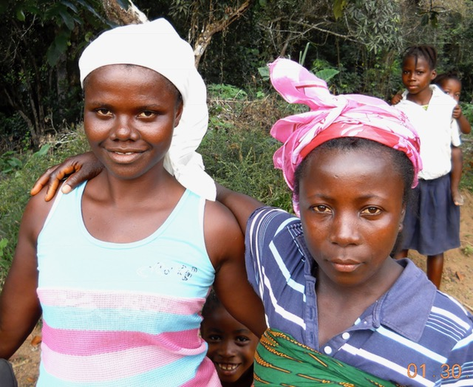Kuwaa Mission distributes Days for Girls kits throughout the Kuwaa Chiefdom, providing health education and sustainable feminine hygiene kits for the Kuwaa girls. Several church groups, quilt clubs and sewing groups work to sew and assemble Days for Girls kits.  These sustainable feminine hygiene kits will last a girl for up to 3 years. Even more importantly, the kits are distributed with health education. The girls are taught their worth, how their bodies function, and how the human race continues because of them. Girls replace confusion and shame with knowledge and dignity. As Celeste Mergens, founder of Days for Girls International, says “Each kit is a reminder to the girl who receives one, that she is loved, that she is worthy of education, and opportunity. That she matters.”

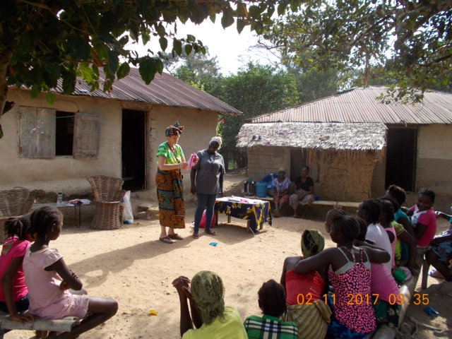Kuwaa Mission recently shipped 496 Days for Girls kits for distribution throughout the Kuwaa Chiefdom. Each kit contains: 2 pairs of panties, 2 washable panty shields with pockets, 8 washable flannel liners, a washcloth, a bar of soap, 2 Ziplocs for soaking and washing the items, all in a cotton drawstring bag. Those 496 kits represent 89,280 days that girls can remain in school and active in their communities. The kits will be distributed by Korpo Barsay, Kuwaa Mission’s Liberian health worker. They will also be distributed by Jenny Cosgrove, Kim Tahini, Laurie Juelg and San Olsen when they travel to Kuwaa next spring. Please pray for our mission.

A special thanks to the groups and individuals who sewed and assembled the kits for this shipment: Lord of Life Lutheran Church (North Pole, AK), Cross of Christ Lutheran Church WELCA (Welch, MN), Sun City Summerlin Quilt Club (Las Vegas, NV), Terri’s Friends (Reno, NV) and Christ our Savior Lutheran Church (Anchorage, AK). Days for Girls International ([www.daysforgirls.org](http://www.daysforgirls.org)) has developed and field tested the kits and the educational programs. In the past 10 years, over one million kits have been distributed to girls in over 100 different countries by DFGI. Kuwaa Mission is pleased to be partnering with this organization.

Your donations to Kuwaa Mission make the transportation and distribution of the kits possible. The area is remote, and the logistics are complicated. Kuwaa Mission also supports continuing health education for our health worker Korpo Barsay. We are also working with Lutheran Church in Liberia to help facilitate setting up a micro-enterprise to sew kits at their women’s’ center in Monrovia at some point in the future. We welcome individuals and groups who would like to sew and assemble Days for Girls kits. For more information, visit our Kuwaa Mission website ([www.kuwaamission.org](http://www.kuwaamission.org)).

With gratitude,

Sue Zager – your fearfully and wonderfully made sister in Christ

Days for Girls - Kuwaa Mission Partnership Coordinator email:summerlinlvnv@daysforgirls.org

Please reach out at [Webmaster@kuwaamission.org](mailto:Webmaster@kuwaamission.org). with questions or if you want to help!

Your contributions to the Kuwaa Mission are tax-deductible. We are a 501c3 non-profit organization. Our tax ID number is 27-5458111

[](https://smile.amazon.com/)