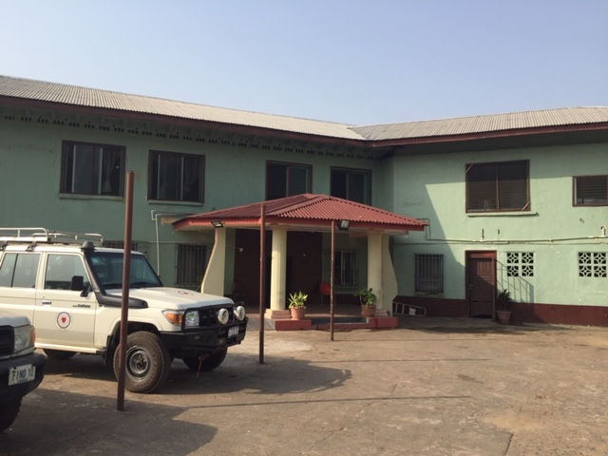Dear Kuwaa Mission Supporters,

The New Year brought Stan Olsen, Kuwaa Mission CEO, to the Cosgrove residence in California, on Jan 7th from Alaska. Stan and Jenny Stelling Cosgrove, Kuwaa Board member left for Liberia on Jan 8th. They had stops in Montreal, Brussels and in Sierra Leone before landing at Robertsfield. Lutheran friends met them and transported them to the Lutheran Guest House in Sinkor.

Once settled in they met with Bishop Seyenkulo of the LCL and Bishop Bolay of the ELCL. Supplies up country were purchased in Monrovia. and touching base with Samaritans Purse was essential (at that time they did not know if transport via SP helicopter was available). They did get the ok for a ride to and from the villages. Praise God for Samaritan’s Purse! The February Prayer Letter will be about their trip.

February also is the 10th Anniversary of the Kuwaa Mission. Rev Dr. Richard Thompson and Bishop Jensen Seyenkulo are the founders of this mission. Several celebrations will be held in February and a special New Year/20th Anniversary card and Prayer Letter will be forthcoming.

The Kuwaa Mission board is comprised of all volunteers. This year several board members will be retiring from the board. If any of you feel led to help us by being a board member, we would love to hear from you. We always appreciate new people. The Kuwaa people need our help.

The board currently has approved $600 for the continuation of evangelist training in Totota. We have approved $650 for motor bike transportation between villages if needed. Funds also have been approved for bringing supplies for well repair in Belle Yelleh. Stan carried 3 large bags of Days for Girls kits. Jenny brought 1 large bag and Big Belly books to share with each village. Satellite communication reveals all is successful so far.

For the Kuwaa Mission Team,

Diane Stelling - Member of the Board of Directors  
PS: If you are interested: Google Big Belly Liberia and Days For Girls

Please reach out at [Webmaster@kuwaamission.org](mailto:Webmaster@kuwaamission.org). with questions or if you want to help!

Your contributions to the Kuwaa Mission are tax-deductible. We are a 501c3 non-profit organization. Our tax ID number is 27-5458111

[](https://smile.amazon.com/)