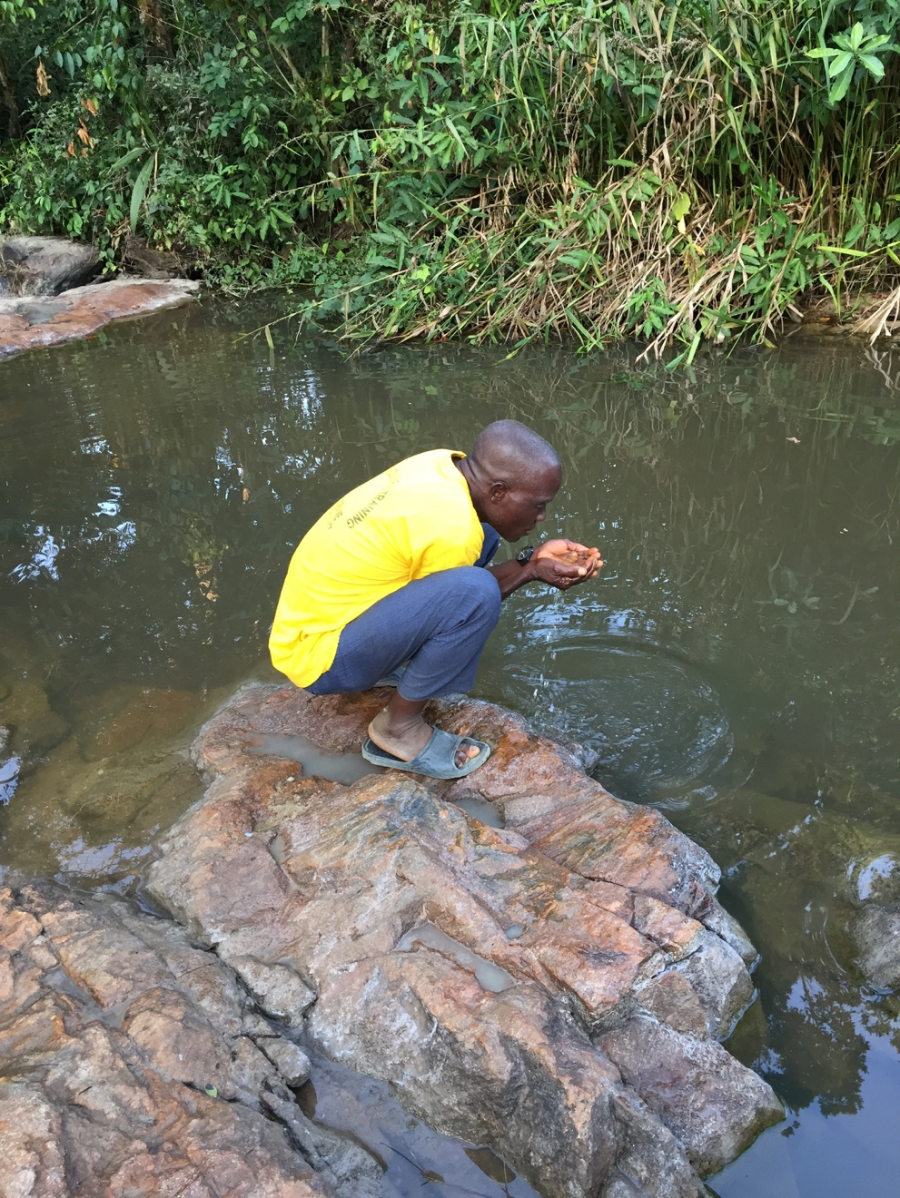Imagine that you get up one morning, walk into your kitchen to put water on for coffee or tea – and no water comes out of the tap. You look around and maybe find a few water bottles or ice you can use – but what next? You cannot shower! You cannot do laundry! What would you do if the nearest grocery store is miles away- and you have no car because there is no road to your village? The nearest source of water is a dirty creek that is drying up in the hot, dry season.

This situation is happening daily in remote villages in Liberia, West Africa. The water wells they depend on for drinking and cooking may break down or run low during dry season. For example, in the town of Gatema that Stan Olsen and I (Jenny Cosgrove) visited in January, one old well hasn’t worked in years and the one which the Kuwaa Mission installed several years ago, was going dry. It is not that far into dry season and already the villagers were using it for drinking water only, and families were rationing their use to every other day. Sadly, we have since gotten reports that they are resorting to using the dirty creek for drinking water again.

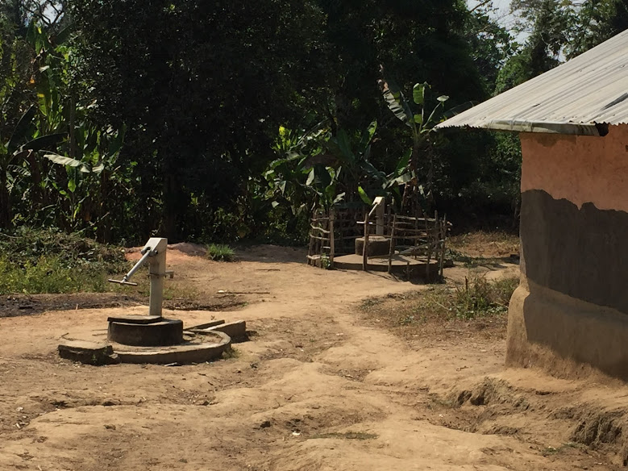Safe drinking water has resulted in better health, thus children and adults are living longer. The village populations are increasing and the current pumps are used more often. These pumps need periodic repairs and there is a need for more and deeper wells in the towns as well.

We are really excited by a new development in well drilling – our new hand drilled (instead of hand dug) well in Fassama is deeper than any of our older wells. This new approach is needed in so many villages where the water table drops as the dry season progresses. We are asking for your help to repair wells and dig more of them for the Kuwaa people in remote villages. This season, we have already repaired or dug/drilled seven more wells, but it hasn’t been enough.

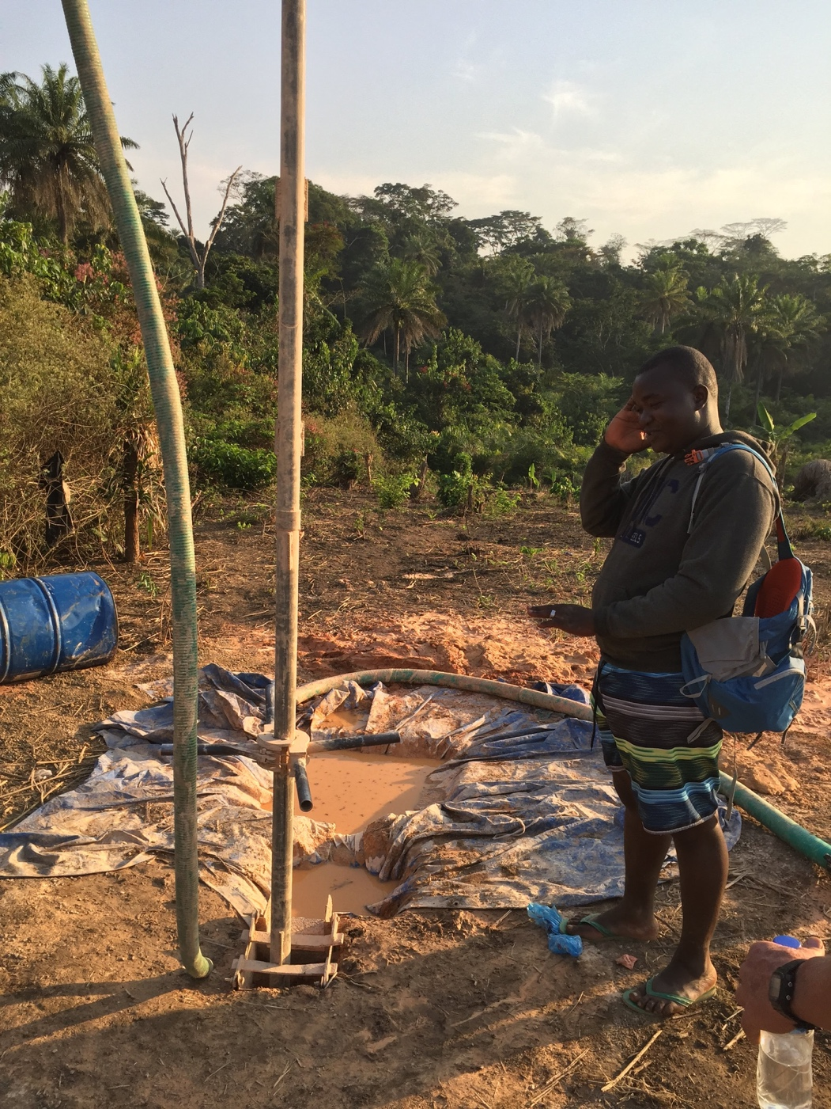**The need is great and urgent.** Your one time or monthly tax deductible donation can bring drinking water to so many who need it. On the Kuwaa Mission facebook page or website you will find a donation link. Alternatively, you can mail a one time or monthly contribution to assist us in providing clean water upcountry. It may not seem like a lot, but $5 a month from many caring people would go a long way to providing clean water for a village. Will you please help us?

We also would like to suggest a new program where we pair groups such as congregations, schools, and charity groups with specific projects. Your partnership could include clean water wells, assistance for school children and their teachers, women’s health programs, and/or assistance to village churches and evangelists. Please contact Stan Olsen if you would like to learn more about this special program. ( [solsen@kuwaamission.org](mailto:solsen@kuwaamission.org) )

As always, we are so grateful for your prayers and your support. The Kuwaa people also send their greetings and many thanks for your help. They thank God for you and so do we.

Na mama o - (thank you in Kuwaa).

We have changed our mailing address for the receipt of donations. All donations should be addressed to the Kuwaa Mission at:

PO Box 90513

Anchorage, AK 99509

Please reach out at [Webmaster@kuwaamission.org](mailto:Webmaster@kuwaamission.org). with questions or if you want to help!

Your contributions to the Kuwaa Mission are tax-deductible. We are a 501c3 non-profit organization. Our tax ID number is 27-5458111

[](https://smile.amazon.com/)