Dear Friends of the Kuwaa Mission:

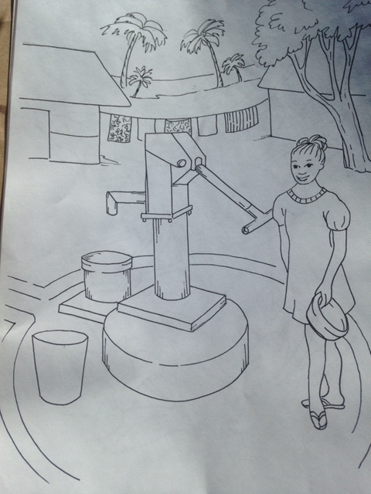Kids4Kuwaa is a special project of the Kuwaa Mission, providing needed funds for the Kuwaa children living and going to school in their remote villages in Liberia, West Africa.

Kids4Kuwaa began some 10 years ago with a young 8th grade girl in Alaska who wanted to help the Kuwaa children. She collected “noisy offerings” of loose change deposited in small metal buckets during the offering portion of the church services. Since then, many churches, Sunday schools, Christian/Lutheran schools and Vacation Bible Schools have also been likewise encouraged and have responded in like manner.

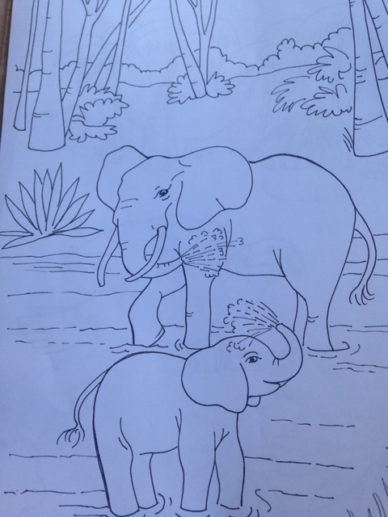Last month for example, Abiding Savior Lutheran School of Lake Forest and Christ Lutheran School of Costa Mesa in Southern California adopted Kids4Kuwaa for their 3rd quarter chapel offerings and raised over $2000 for the Mission. We praise God for their prayers and support of their brothers and sisters in schools in Liberia. Their offerings have been used for school supplies, Christian teaching materials, teacher training, water filters, school repairs and school medical supplies. These schools are located in remote villages off the motor road in a remote area of Liberia.

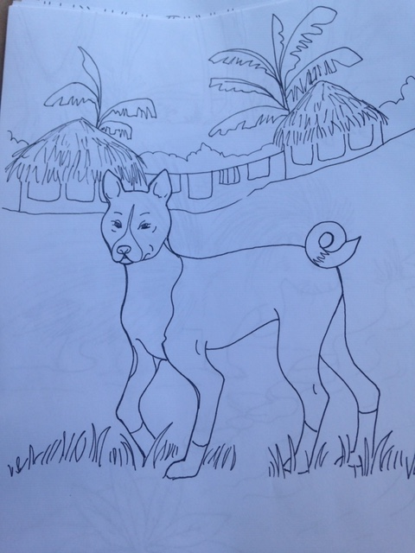Please consider helping these children. Let us know if you would like to adopt Kids4Kuwaa with your Sunday School, Church School, and Vacation Bible School. We have children’s coloring pages, bookmarks and a brief visual presentation available for your use. You may also wish to adopt one of the schools for continued support and share letters with the schools and their teachers.

Thank you and God bless your own personal and/or congregational mission efforts locally and globally as we proclaim that Christ is risen! He has risen indeed! Hallelujah!!

Sincerely in the Risen Christ,

Ed and Diane Stelling

Advisory and board members of the Kuwaa Mission

You may email us at: [kuwaa513@att.net](mailto:kuwaa513@att.net), or [kuwaa5dane@sbcglobal.net](mailto:kuwaa5dane@sbcglobal.net)

You may also call us at: 949/243-6328 or 949/309-8236

We have changed our mailing address for the receipt of donations. All donations should be addressed to the Kuwaa Mission at:

PO Box 90513

Anchorage, AK 99509

Please reach out at [Webmaster@kuwaamission.org](mailto:Webmaster@kuwaamission.org). with questions or if you want to help!

Your contributions to the Kuwaa Mission are tax-deductible. We are a 501c3 non-profit organization. Our tax ID number is 27-5458111

[](https://smile.amazon.com/)