The Kuwaa Mission has completed another year’s work of helping the Kuwaa People as they continue to work to rebuild their lives and communities after years of civil conflict, the Ebola crisis and the ever-present complications of access / transportation to their communities after the heavy rains during our summer months. The roads turn into a clay quagmire that makes it impossible for vehicles to travel upcountry. We have helped rebuild many bridges within their area, but the main road is the government’s responsibility and they have neglected this responsibility since the war started in the late 1980’s.

Inflation and extremely high unemployment remain two of the biggest obstacles to development. While we are able to hire 3-4 people to help us with our programming, the small amounts we can afford to pay them are not anywhere sufficient for their needs and the needs of their families. We continue to work with the Lutheran Church in Liberia to do what we can to install hope for a brighter future.

Our well program continues to excel. To date we have installed 33 new wells, 7 in just this year!! Two wells were hand drilled to a depth of 80’ and are providing abundant water in the large town of Fassama. Our Children’s Bible School this year again had over 100 children in attendance, many of whom were Muslim. Fortunately, both religious groups work and live peacefully and respectfully with each other. We taught stories common to the Koran and the Old Testament. We have distributed well over 100 sanitary napkin kits to adolescent girls and the demand continues to far exceed capacity.

We have helped rebuilt the school in Belle Baloma that now has rooms for K-9 grades, we supplied roofing materials for churches in three villages where they had already begun to make mud blocks to repair / replace their damaged church walls.

We are in the process of developing a program whereby churches, schools or individuals can adopt a village church or school and help in the rebuilding of the facility, providing much needed supplies, training, and hopefully actually travel to Liberia to witness the work they are sponsoring and the work that the Kuwaa Mission has accomplished. If you would like additional information, please contact Stan Olsen at the address on our web page: www.kuwaamission.org.

Below is a list of our accomplishments to date. Thank you for your support over the past 10 years and we join you with prayers for Liberia.

**KUWAA MISSION 10 YEAR ACCOMPLISHMENTS**

* Established an excellent working relationship with the Lutheran Church in Liberia (LCL)
* Visited all 16 villages and in conjunction with the villagers determined their immediate and long-term needs
* Distributed over 150 water filters to individuals, churches, schools, clinics and demonstrated their use
* Provided at least one potable water well in 15 villages, most for the first time
* Installed 33 new wells and rehabilitated over 20 others
* Received 501c3 status from US Government
* Received Non-profit status from Liberian Government
* Provided evangelist scholarships to students at Lutheran Literacy Center (prior to receiving our 501c3 status)
* Provided one nursing scholarship (prior to receiving our 501c3 status)
* Distributed yearly medical supplies for two area clinics for 10 years and conducted nursing workshops at the clinics
* Distributed yearly school supplies to village schools
* Conducted teacher training workshops
* Conducted Children’s Bible Schools for four years with average attendance of over 150 children
* Built a new 9 room clinic with solar power that is now being run by the Ministry of Health
* Rebuilt over 30 bridges to provide access to new clinic and increase economic development of the area
* Partnered with local villages to rehabilitate roads between villages
* Lived, worked, prayed and worshipped with the people
* Instituted “Community Led Total Sanitation” workshops (Highly successful UNICEF program)
* Conducted 5 well maintenance workshops to teach local villagers how to maintain their wells
* Implemented “Days for Girls” program in three villages. Provides reusable, sanitary menstrual kits to school girls

**WHAT HAS THE KUWAA MISSION DONE THIS YEAR: 2019**

* Installed 7 new wells
* Repaired 5 existing wells
* Conducting Children’s Bible School in Lowoma in conjunction with the local Muslim leaders (158 children attended)
* Conducting two sanitation workshops
* Inspected the clinic in Kondesu and met with the staff. Delivered over $1,000 worth of medical supplies
* Conducted Days for Girls workshops in Lowoma, Kondesu and Ballama and delivered over 150 menstrual kits
* Met with Open Society Initiative for West Africa (OSIWA) and the LCL to begin the Big Belly program to teach pregnant women about the changes in their body and proper nutrition. We are also working with the LCL to further the Days for Girls program.

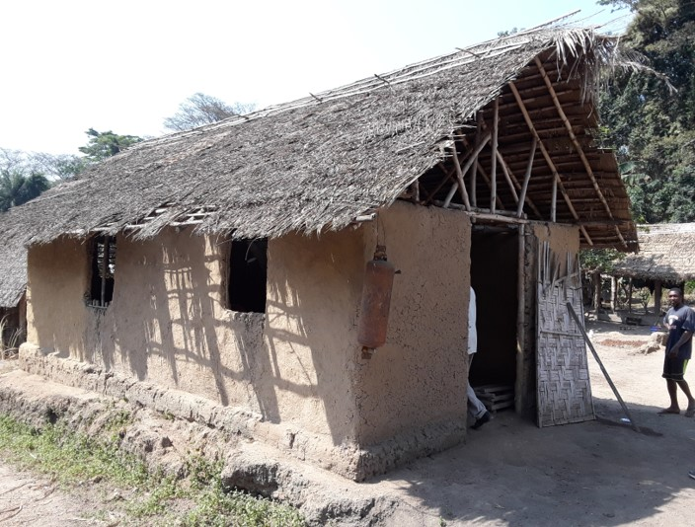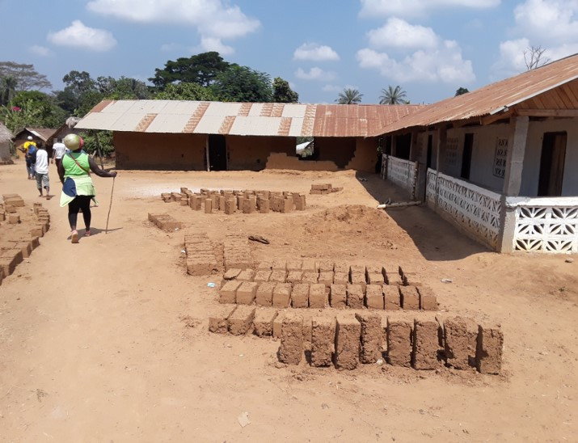

**Picture 1:Lowoma School**

**Picture 2: Bella Baloma School**

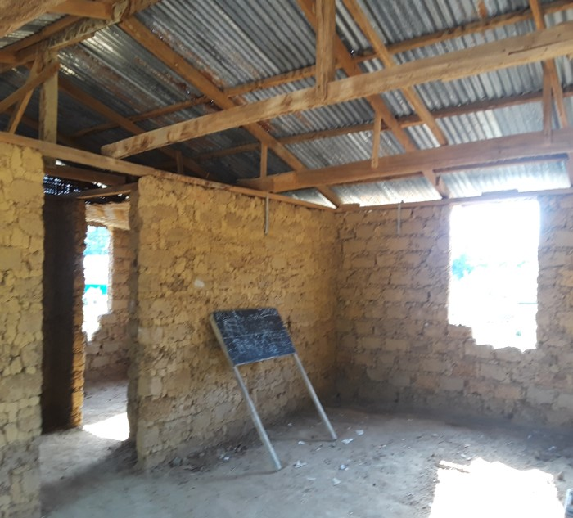

**Picture 3: Gatema Church**

**HOW CAN YOU HELP THE KUWAA PEOPLE?**

* Pray for the people and the Kuwaa Mission
* Become a volunteer in American or in Liberia
* Become a “Partner Congregation”
  + Adopt a church or school
  + Place the Kuwaa Mission in your church budget
* Donate much needed funds:
* $5 provides one child with school supplies for one year
* $15 provide a teacher with supplies for one year
* $15 provides one blackboard with chalk
* $25 provides one rechargeable light
* $35 provides one bag of cement including transportation (25 bags required for one well)
* $350 provides roofing materials for a church / school (material only, approx.. 240sf)
* $800 provides one hand pump (material only) excluding cement
* $2,000 provides labor to dig and install one hand pump
* $5,000 provides one complete well
* $15,000 provides materials for a village church
* $25,000 provides materials for a 4-6 room school house

**CONTACT THE KUWAA MISSION FOR ADDITIONAL INFORMATION @** [**WWW.KUWAAMISSION.ORG**](http://WWW.KUWAAMISSION.ORG)

We have changed our mailing address for the receipt of donations. All donations should be addressed to the **Kuwaa Mission at: PO Box 90513 Anchorage, AK 99509**

Please reach out at [Webmaster@kuwaamission.org](mailto:Webmaster@kuwaamission.org). with questions or if you want to help!

Your contributions to the Kuwaa Mission are tax-deductible. We are a 501c3 non-profit organization. Our tax ID number is 27-5458111

[](https://smile.amazon.com/)