As 2019 draws to a close and I sit here on Thanksgiving Day and realize how much I personally, and we as the Kuwaa Mission, have to be thankful for:

- The Kuwaa Mission is ALIVE and WELL!!!
- We have wonderful individual and church partners across the United States
- We have a strong prayer support group
- We have a strong financial support base
- That we have accomplished so very much over the past 10 years (see the August 2019 Prayer Letter for detailed information)
- That we have a strong viable partnership with the Lutheran Church in Liberia
- That we have a solid financial base (although we can always use additional funds to meet our programming needs!!)
- That we have two strong, capable and trustworthy contractors in Liberia who do our Well construction, Children’s Bible School, Sanitation and Days for Girls programs
- That we have a very committed and dedicated board of directors whose time is totally volunteered and received no monetary compensation
- That we have developed a strong working relationship with Samaritan’s Purse field staff in Liberia
- That we have a positive relationship with people of many faiths in the Kuwaa area
- That we have a good business relationship with many of the commercial businesses in Monrovia from building supply firms to pharmacies to various small transportation entities
- That we have a good relationship with the Ministry of Health in Liberia
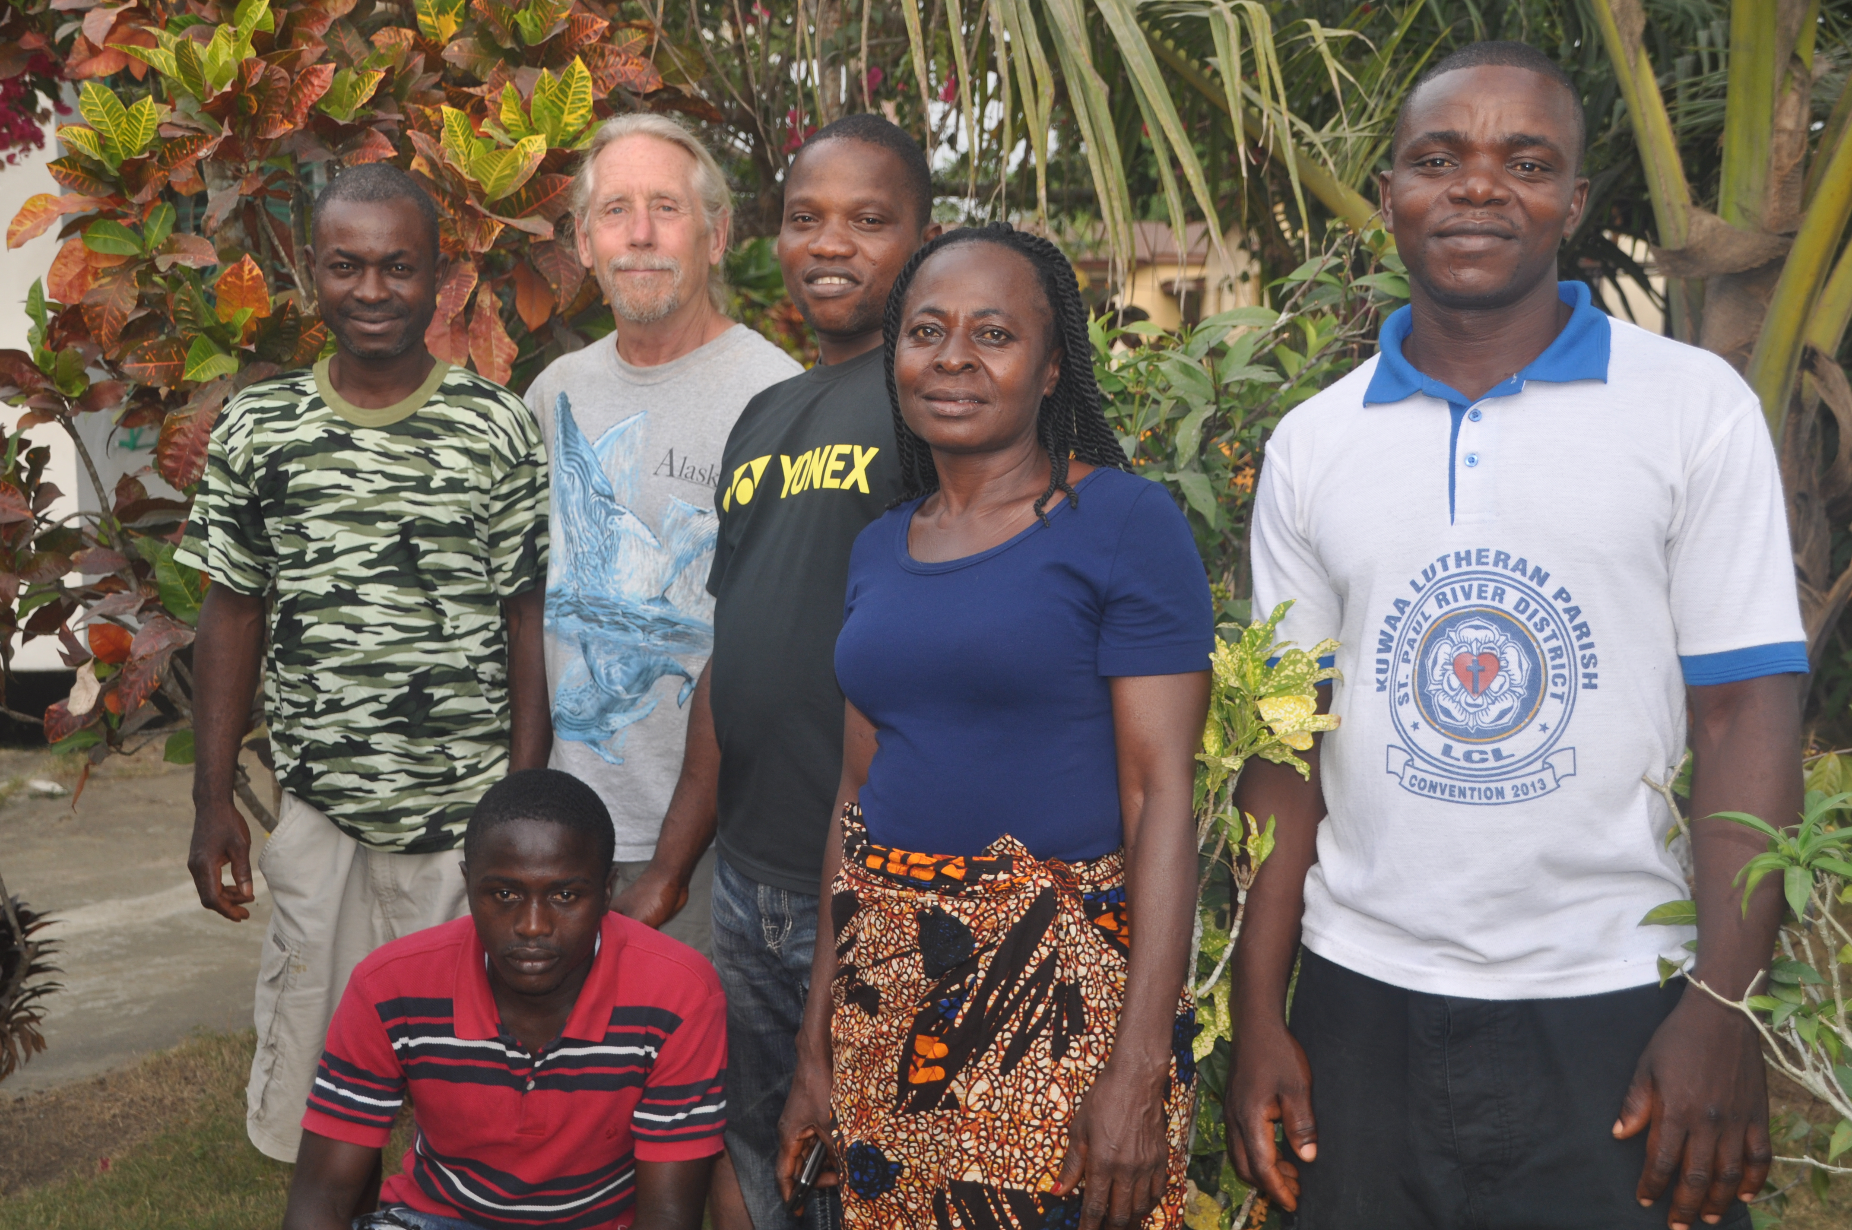
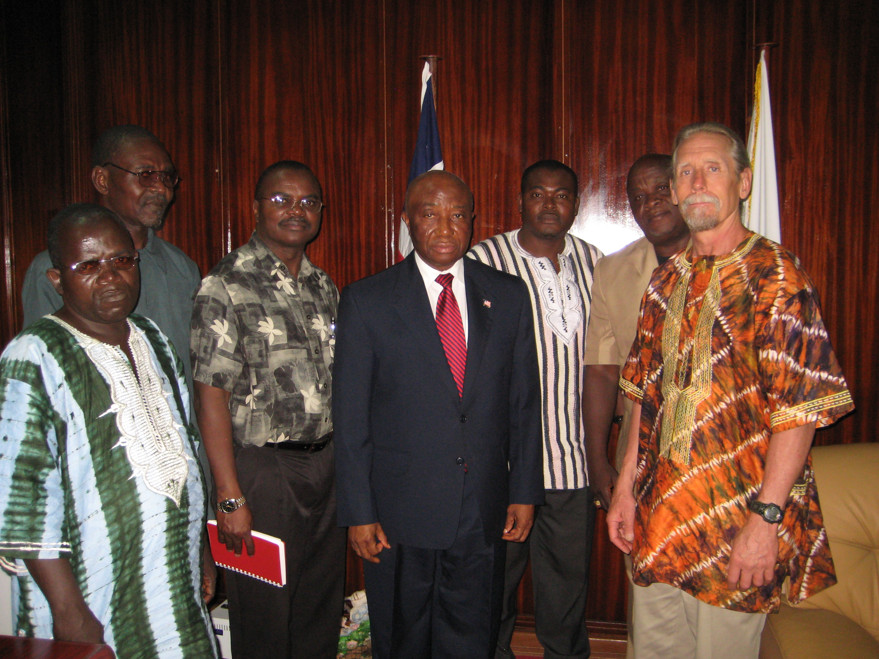
- That we have established a relationship of trust and mutual expectations with the Kuwaa People in Liberia
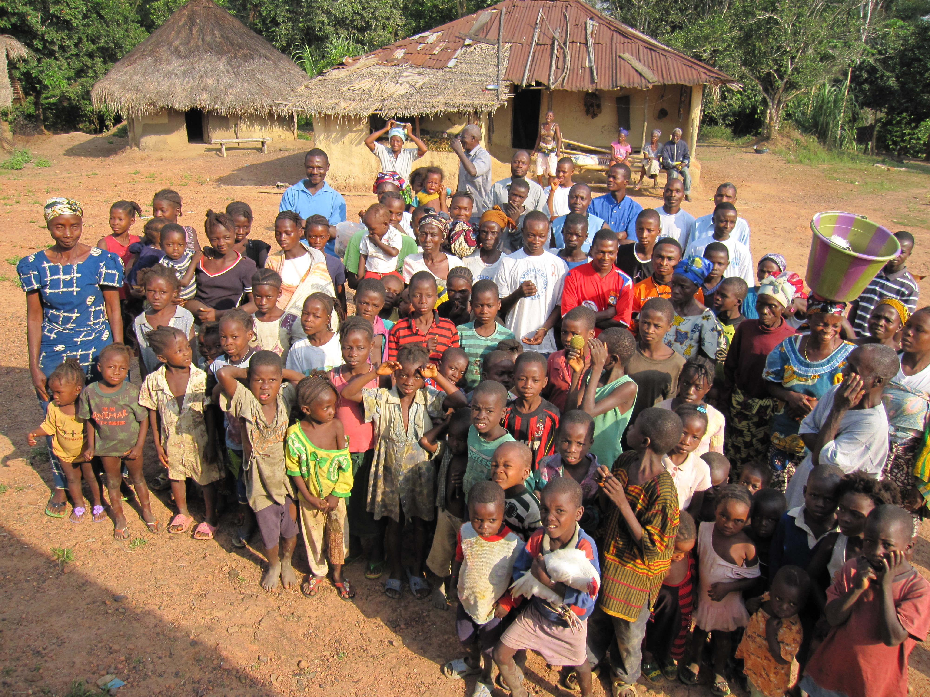
As with all volunteer organizations, indeed all organizations, we are currently looking at our past accomplishments and our future hopes and dreams and the best way to meet those ideals, all based on the expressed wishes and needs of the Kuwaa People. Our relationship with the Lutheran Church of Liberia helps us focus on the best way for us to meet those needs in a culturally sensitive and acceptable method.

As your year draws to a close please take time examine what you are thankful for and how God has blessed your life. Yes, we all have experiences and trials that we undoubtedly wished had turned out differently, but we have been so very blessed as individuals, churches and citizens.

Thank you for your support and I pray that you will continue your prayer and financial support in the months and years to follow.

Stan Olsen
CEO

We have changed our mailing address for the receipt of donations. All donations should be addressed to the Kuwaa Mission at: PO Box 90513 Anchorage, AK 99509

Please reach out at Webmaster@kuwaamission.org. with questions or if you want to help!

Your contributions to the Kuwaa Mission are tax-deductible. We are a 501c3 non-profit organization. Our tax ID number is 27-5458111


